1. Assume N26 wants to send surveys to our customers over the Salesforce Service Cloud.

Batch Apex runs everyday

VF email template

Render based on langCode

Process builder starts

Update a boolean field on Contact SurveySentEmail

Send Email and Update the SurveySentEmail,Survey Date fields

1. we’d like you to display the customer’s product information to the agent whilst they’re interacting.

Existing product list associated to a customer derived based on country.

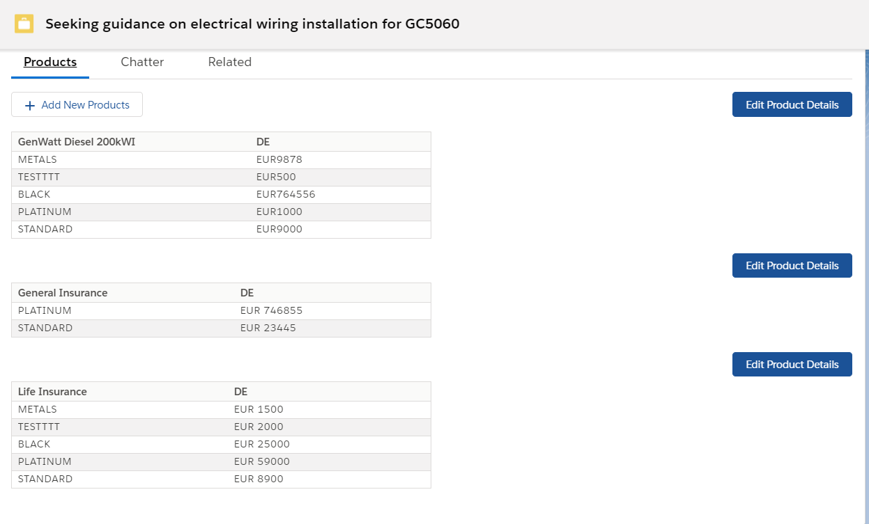

Edit Action with Ability to add new product type

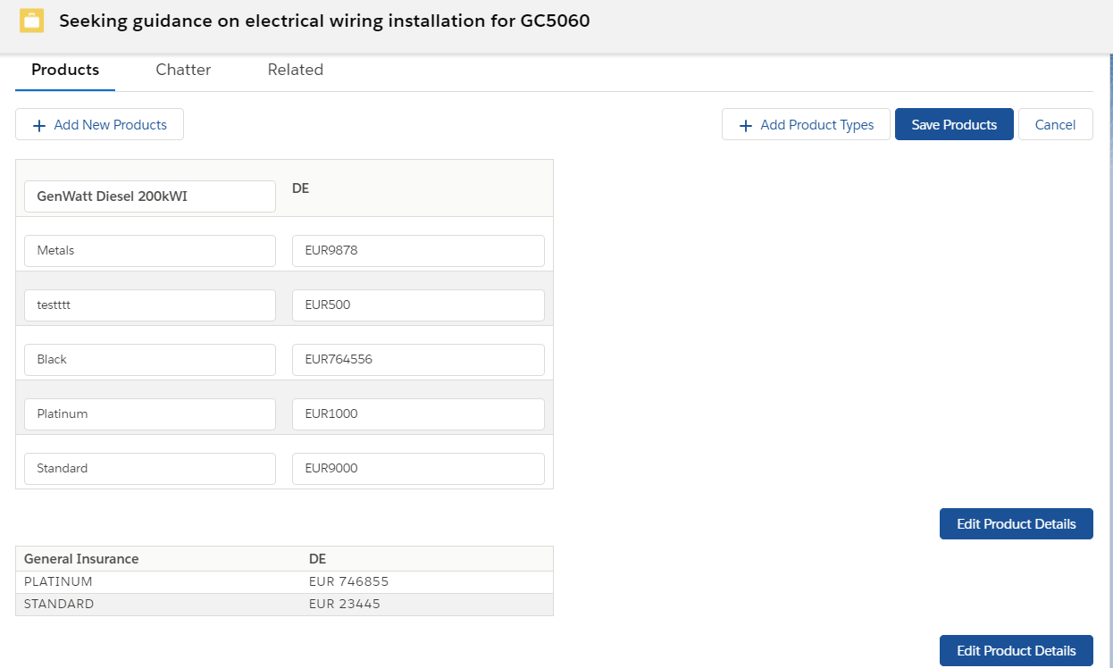

New Type Added in existing product

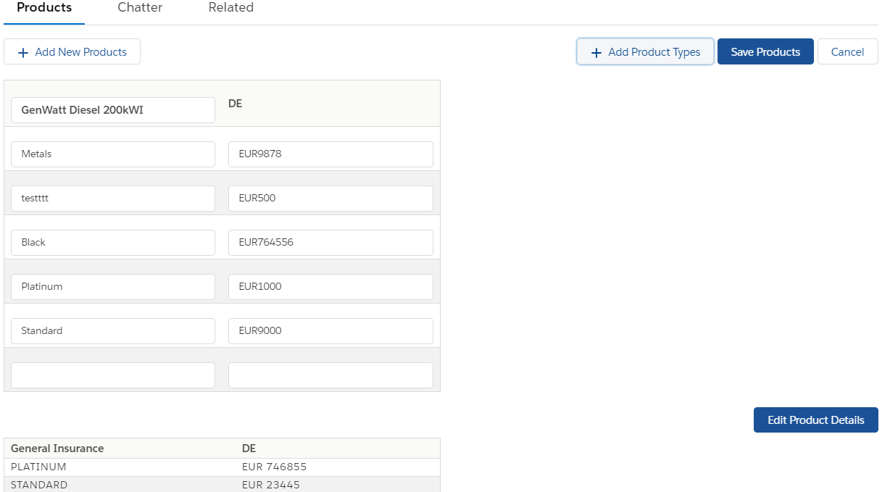

New Product Modal Window

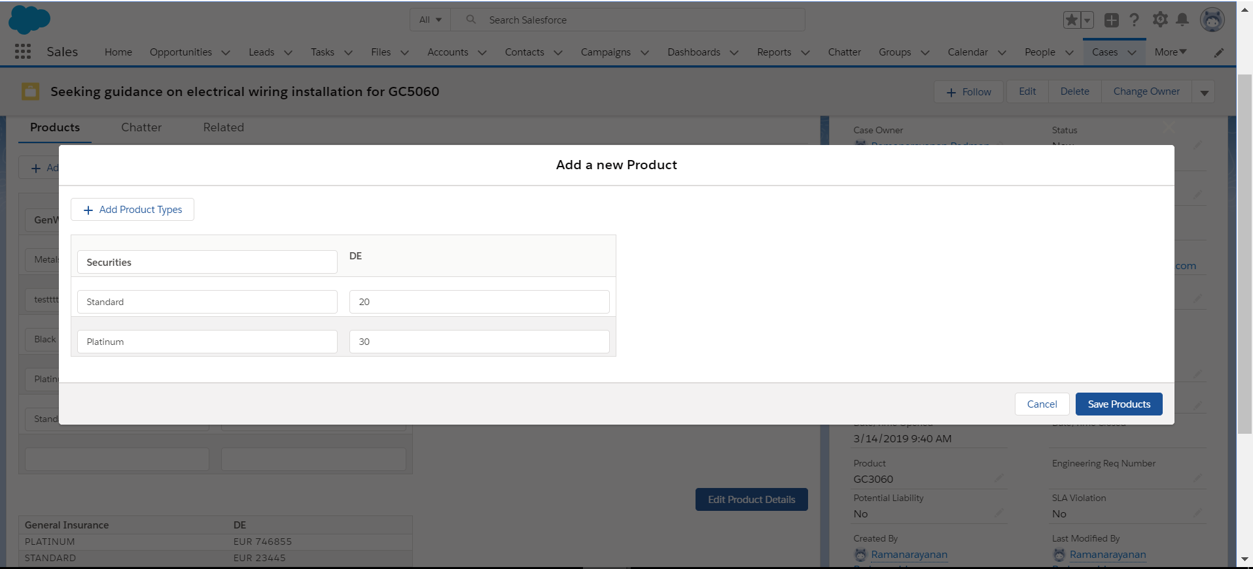

New Product Added:

